George Washington and

the General’s Dog

Name________________________

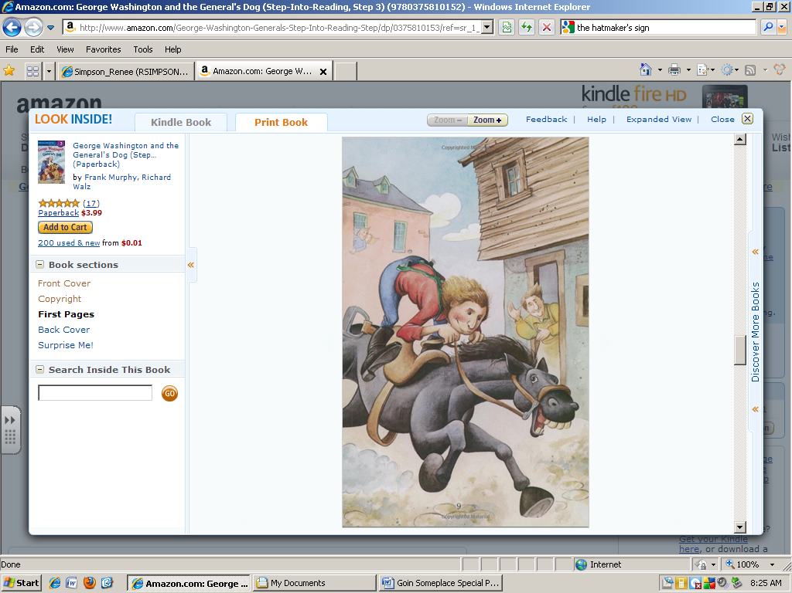

George was __________ at riding horses.

excellent scared silly

The horse is making __________ fly under his hooves.

birds planes dust

The lady is probably __________ of George.

proud mom mad singing